27. Outbound Messages and Time Based Trigger - 31 March 2022

1] Workflow Action = Outbound Messages

2] Time Based Workflow / Trigger

1] Outbound Messages

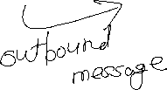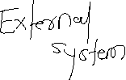

User Story 1] Whenever a new Opportunity is Created and Send Opp Information to HOOKBIN.

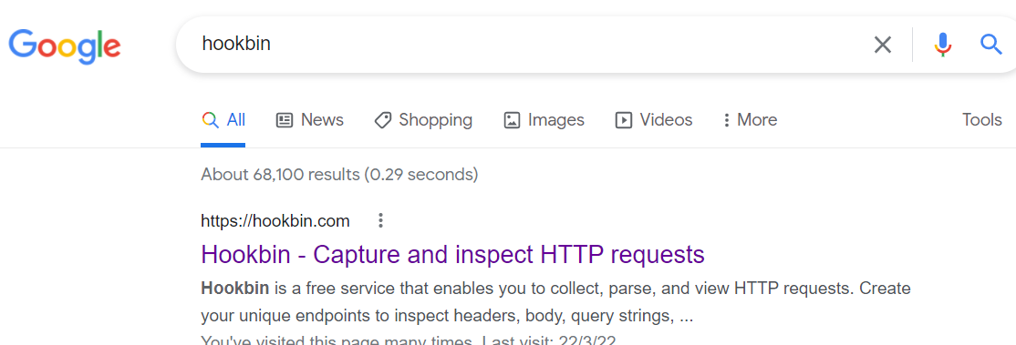

<https://hookbin.com/>

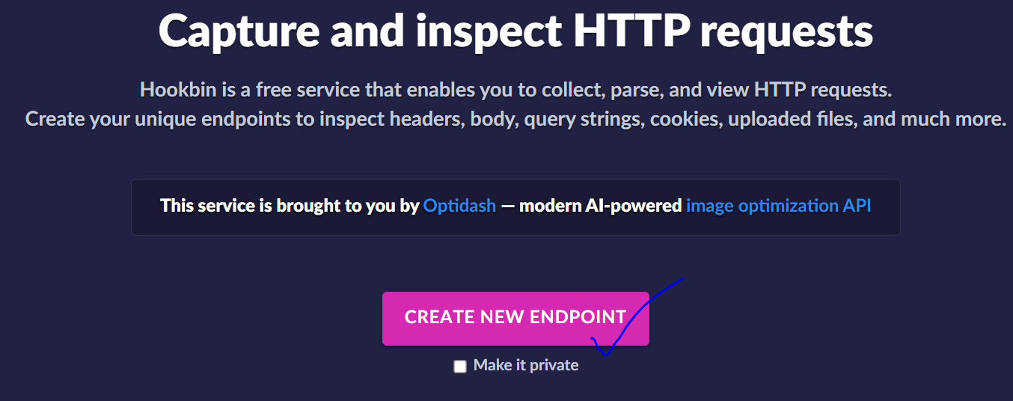

<https://hookb.in/RZakk0XDPBUNb9zzBgMX>

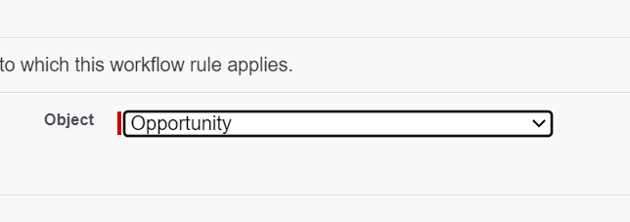

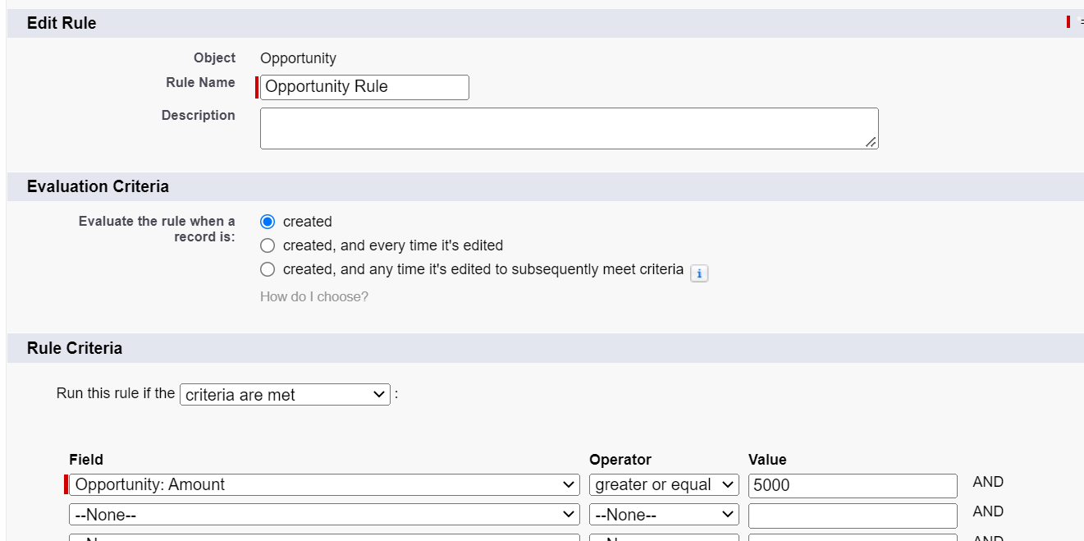

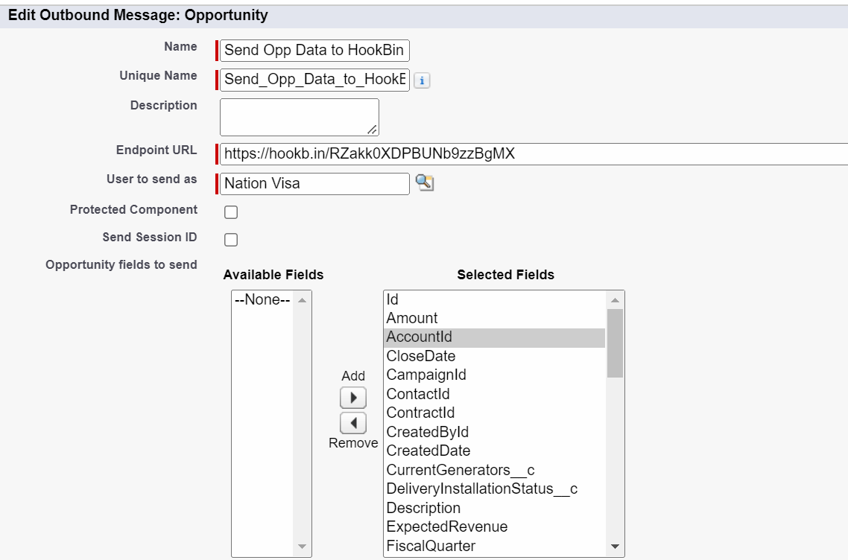

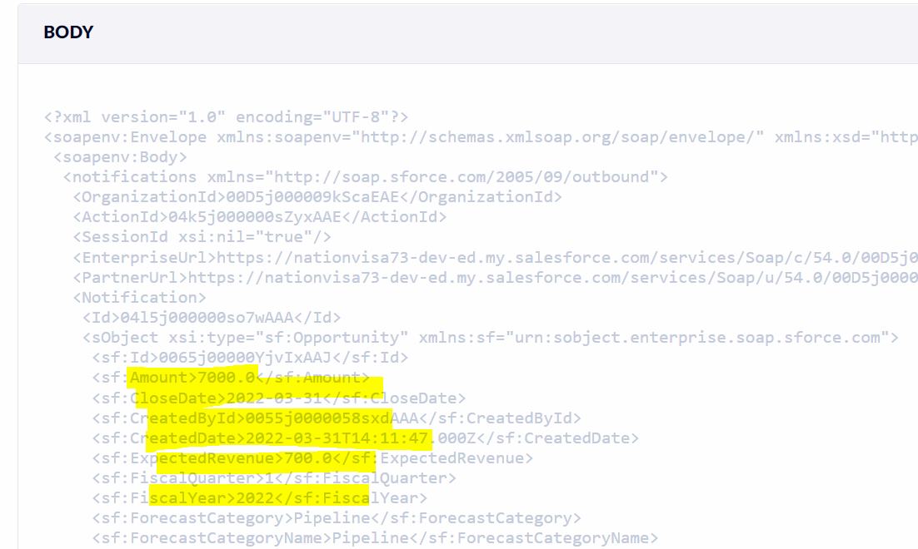

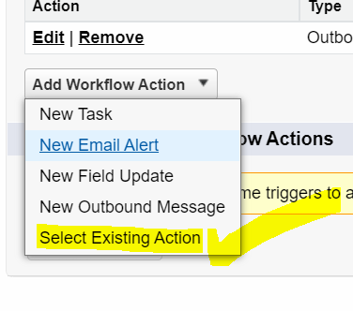



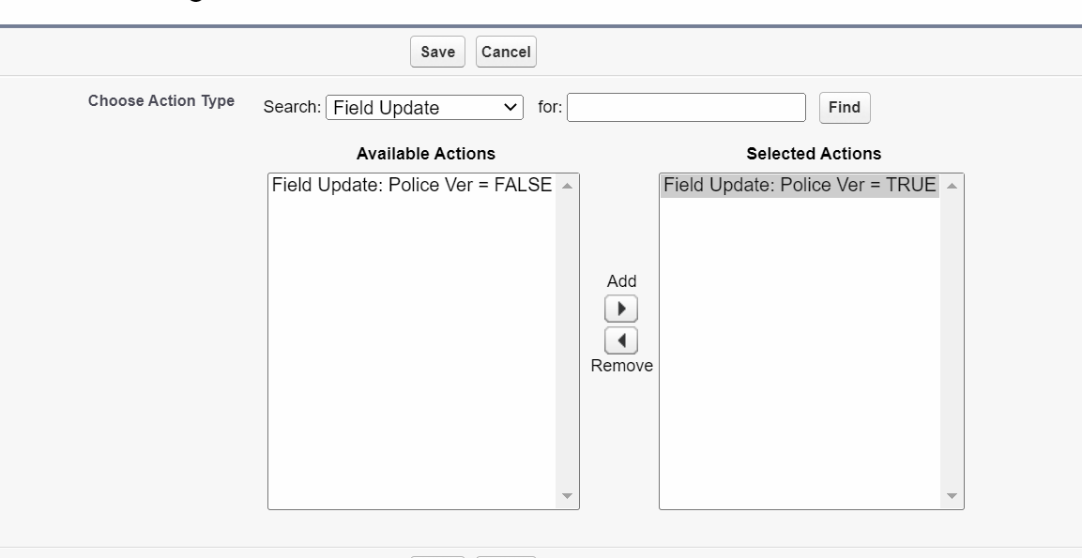

2] Time Based Workflow / Trigger

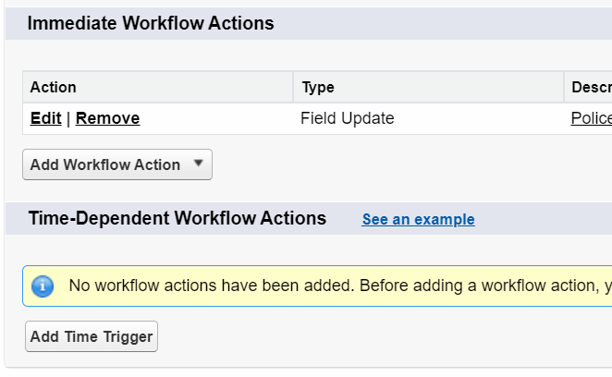



Workflow Action Types - 02



* Immediate Workflow Action/ Synchronous

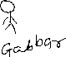

* Time Dependent Workflow Action / Asynchronous

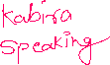

Time Dependent Workflow Action

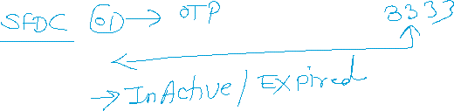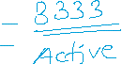

User Story 1] Create a field “OTP” (06 Length) on Applicant.

Create a Checkbox Field “isOTPActive”.

Whenever a Applicant record is created, send this OTP in Email to Applicant.

And Expire this OTP after 01 Min.

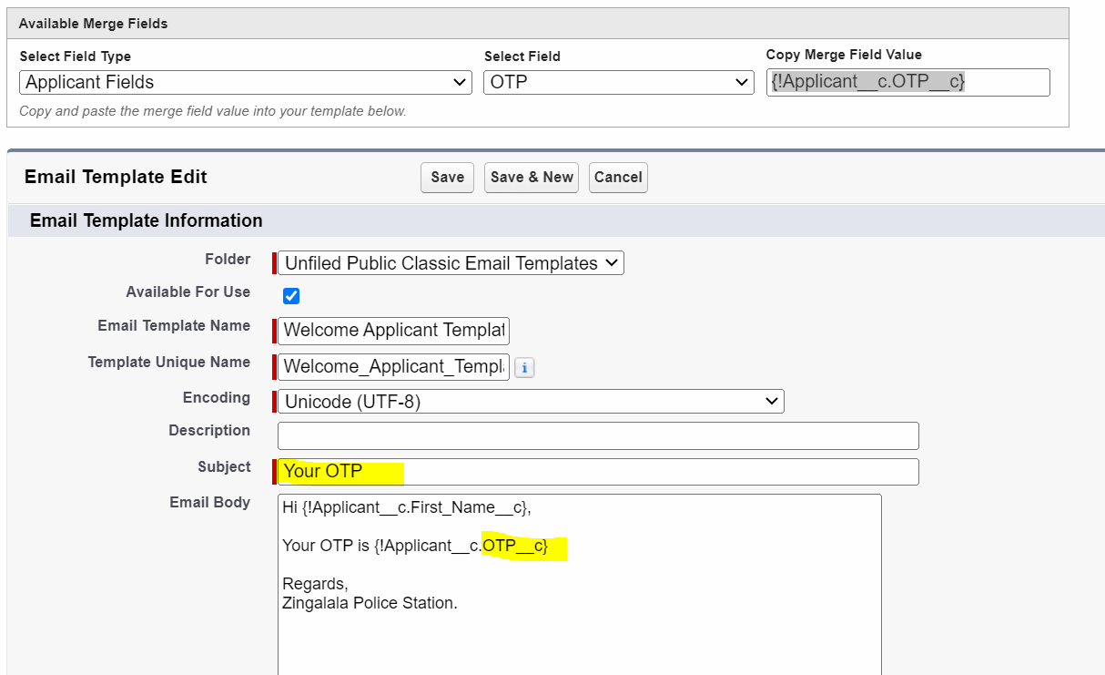

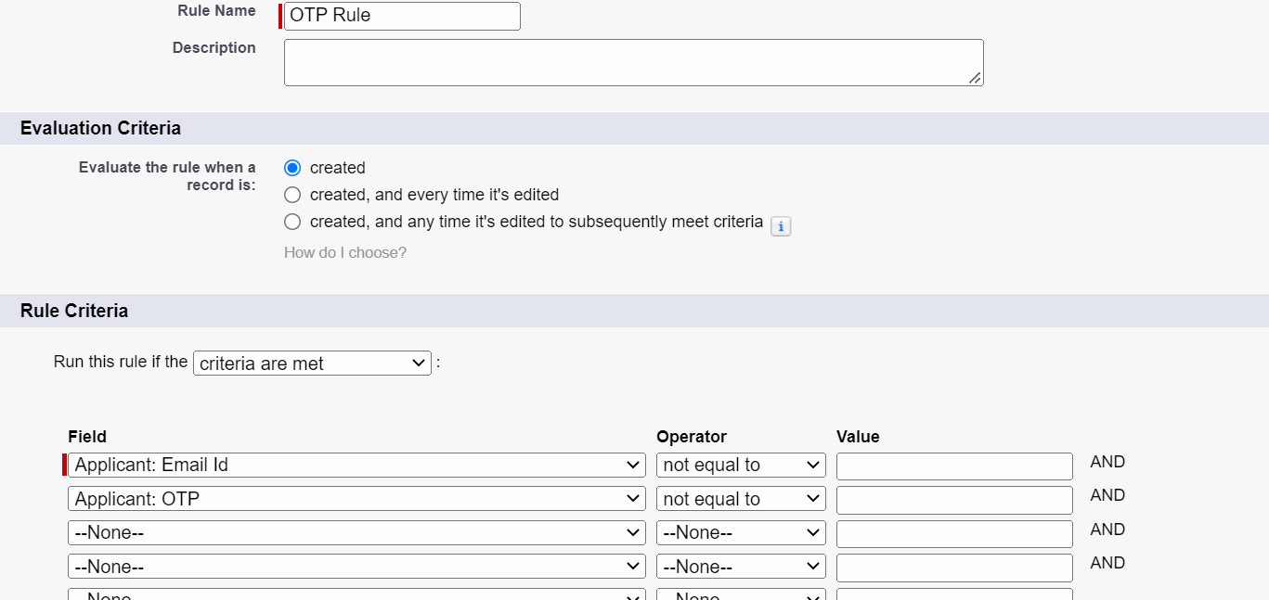

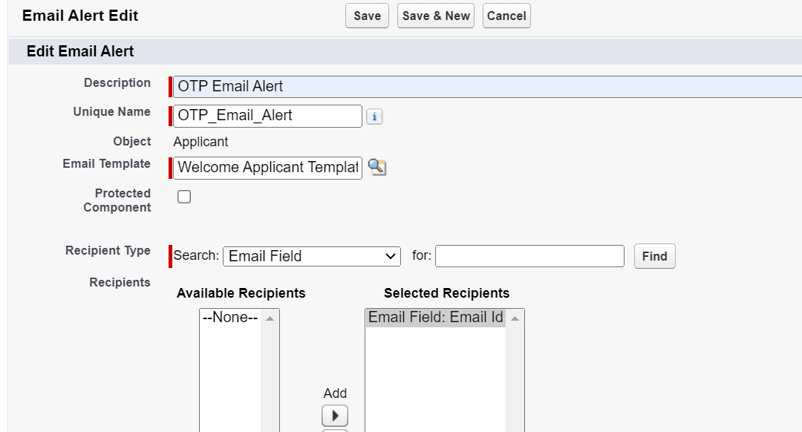

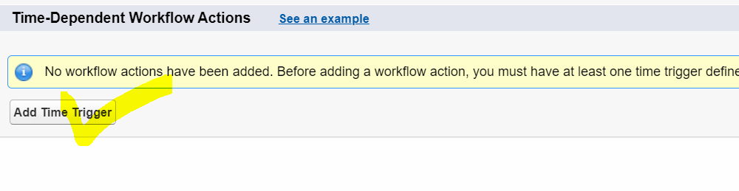

Created Time :  31/03/2022, 8:21 pm



Formula Field 🡪  31/03/2022, 8:22 pm 0 Hours of 8:22 pm



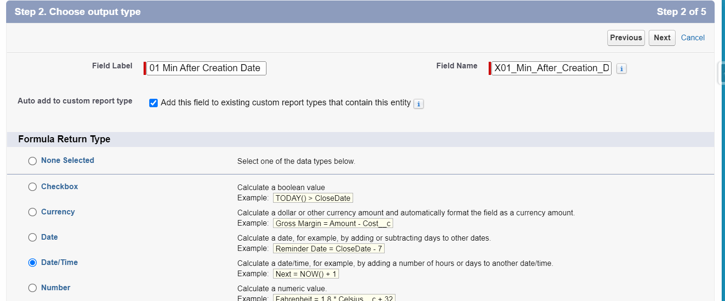

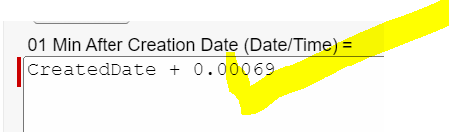

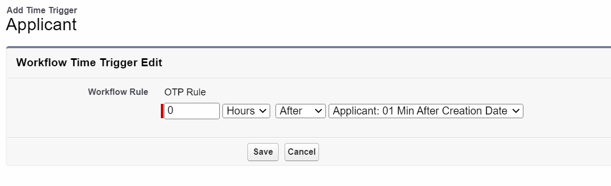

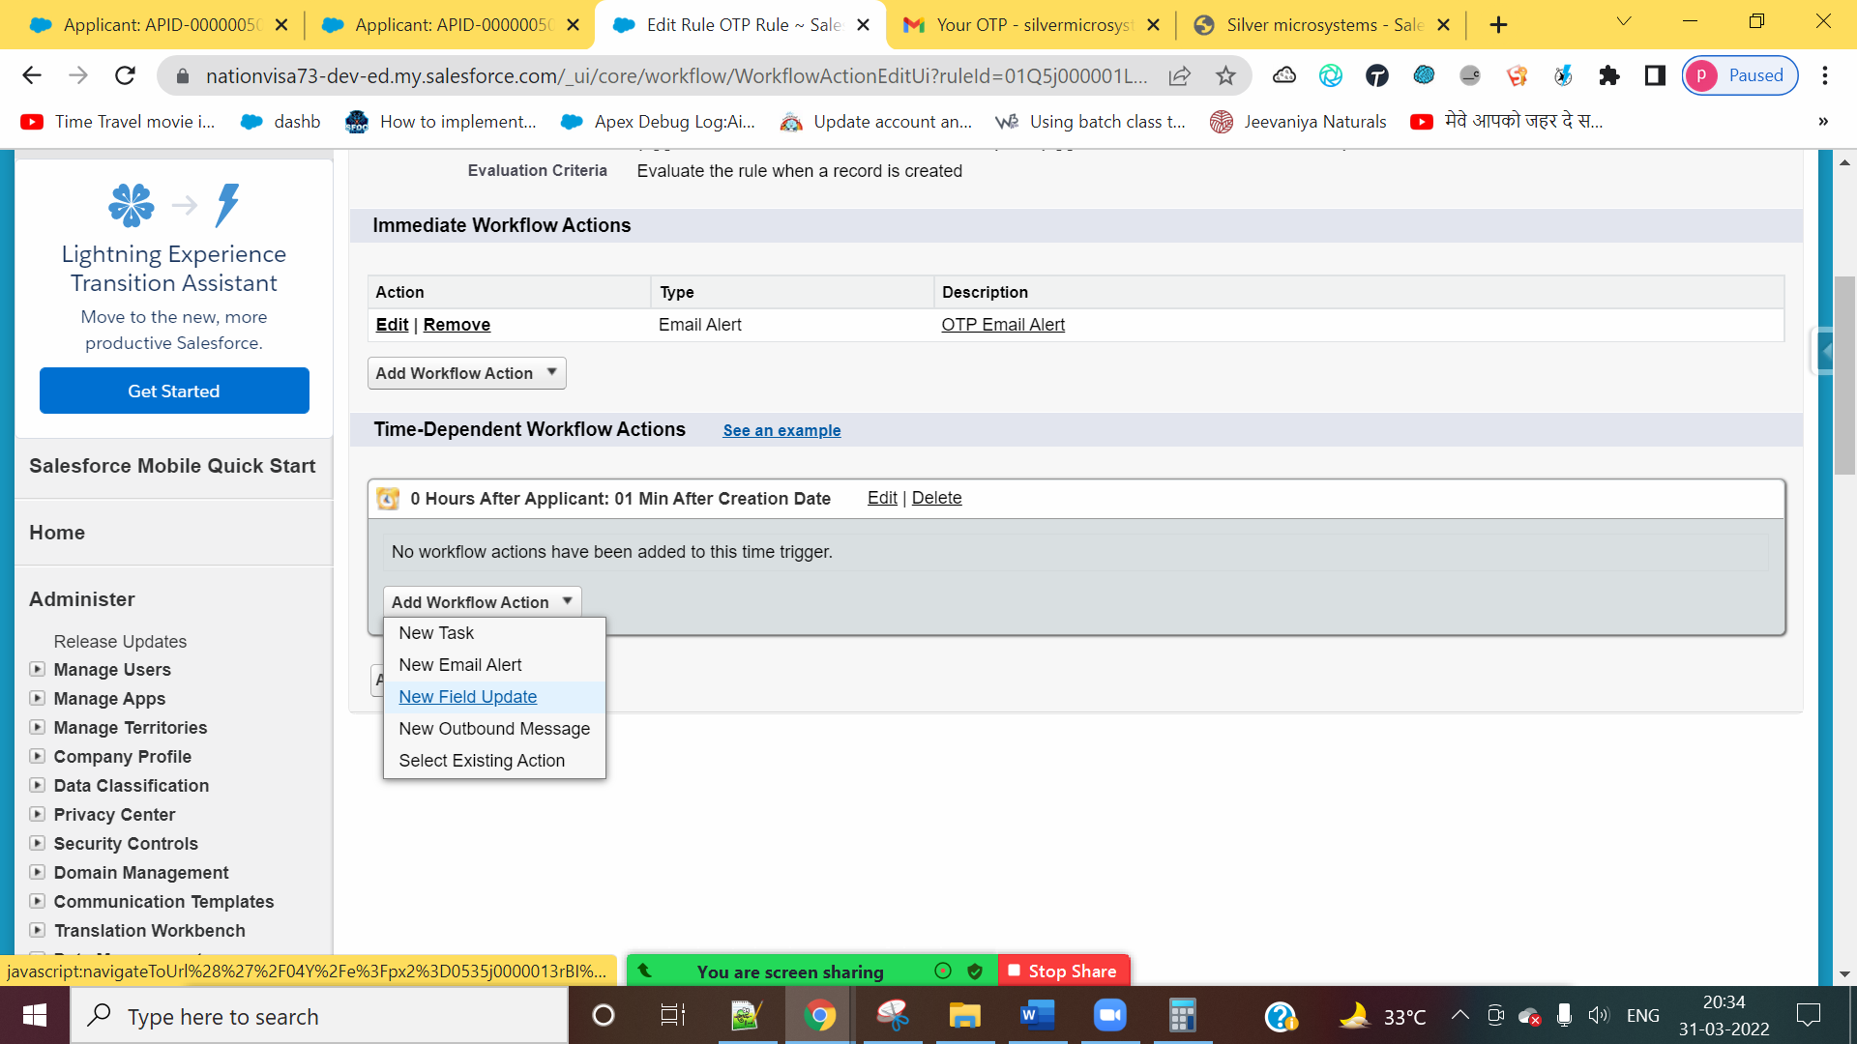

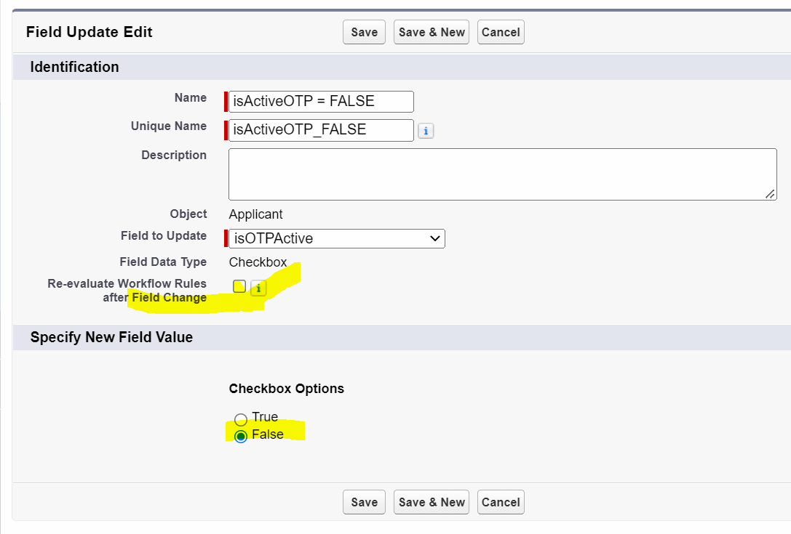

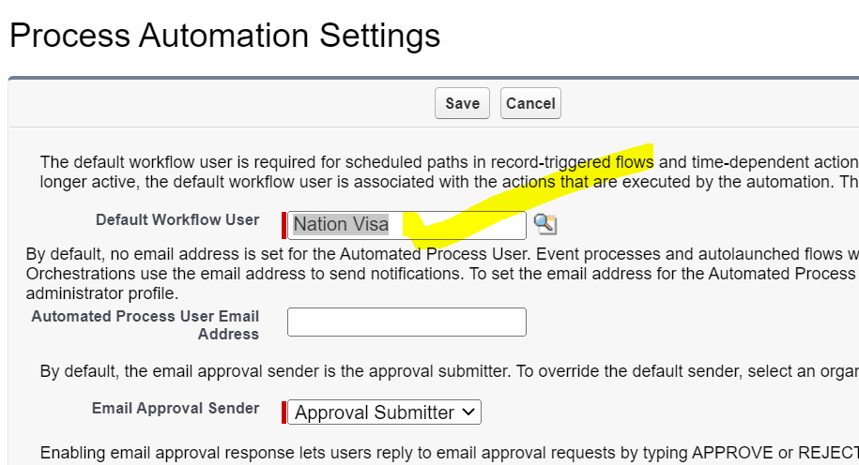

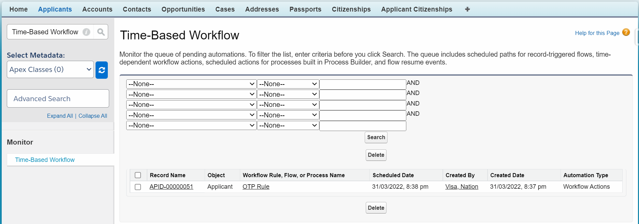

Time Based Workflow Action 🡪 INTERVIEW QUESTION

1] On which Evaluation Criteria, we can not create Time-Based Workflow Action.

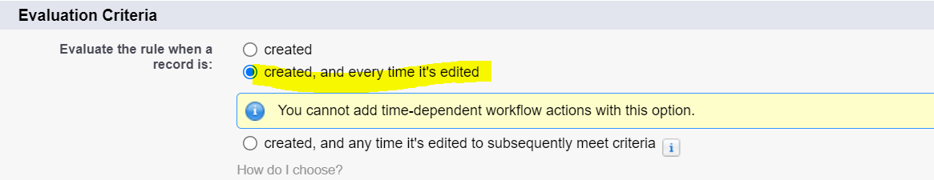

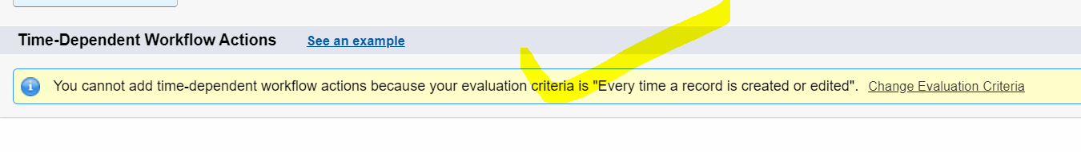

2] If Time Based Workflow Action is in the queue (Time-Based Workflow), I don’t want to execute this action. What should I do.

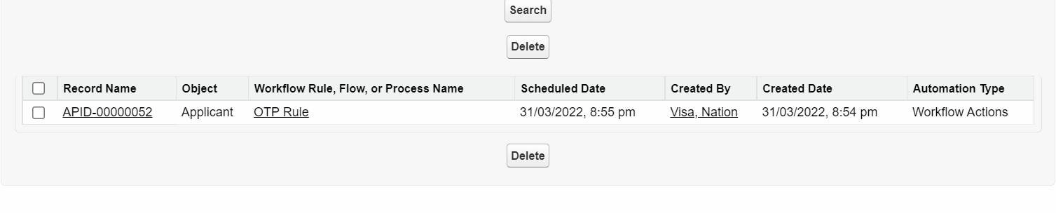

A] Delete the Action from the queue.

B] Make Records condition FALSE

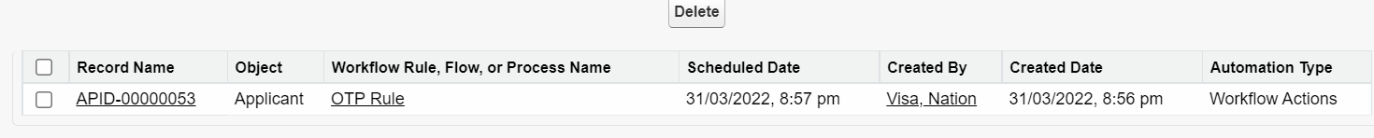



3] Time Based Action is waiting in the queue. Now, I De-Activate the Workflow Rule. Now What will happen.

